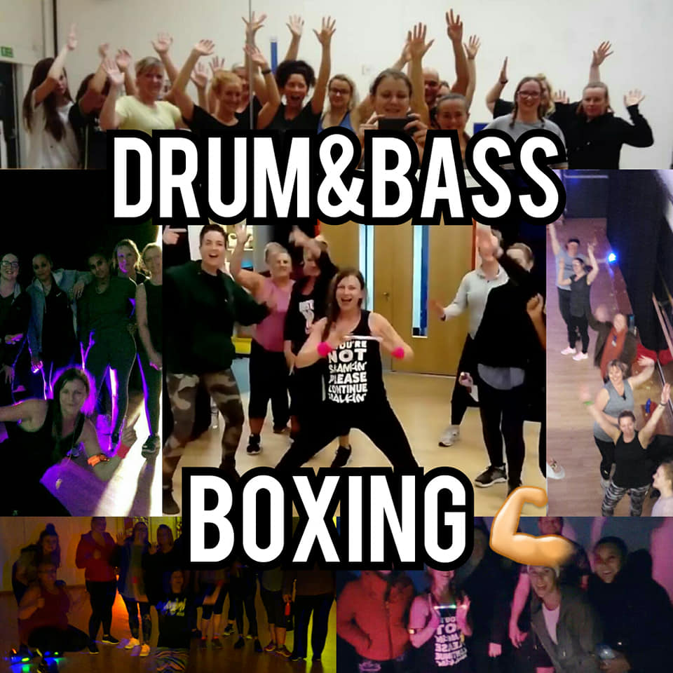

MONDAYS 8:15PM
WEDNESDAYS 7PM
MEMBERS FREE / £5.50 PAYG / MOVEGB
Email Holly for more info: hollyjackson.pt@gmail.com
(Facebook page: Circle Fitness Bristol)

