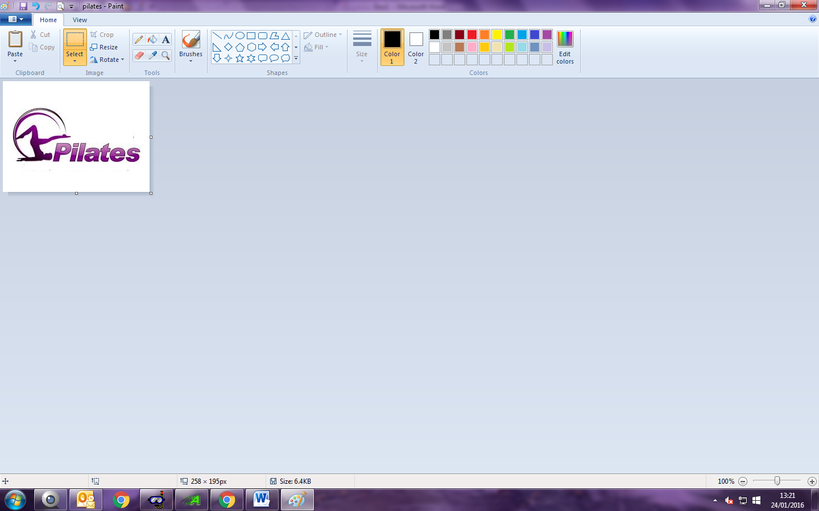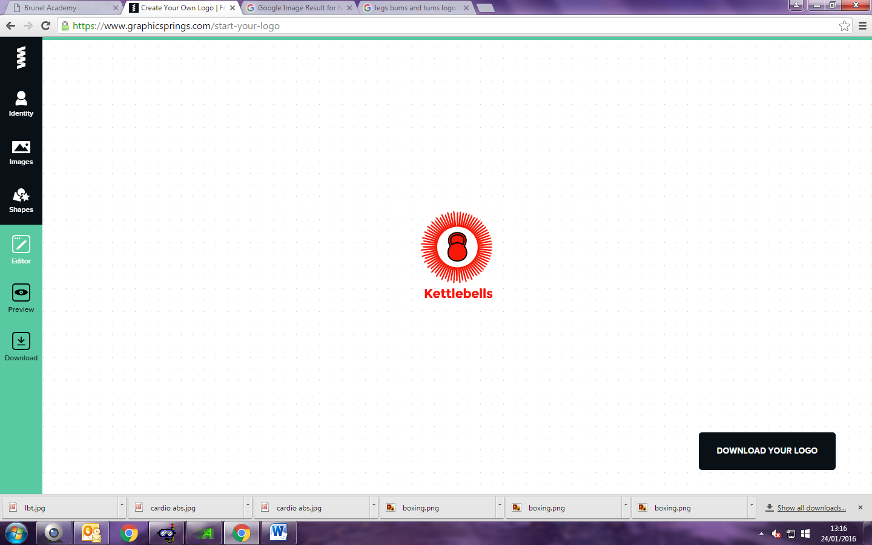

A class built around strengthening up and toning your lower body including your thighs, stomach and bottom.

LBC

Lower Body Conditioning

A body conditioning routine that will help to build flexibility, muscle strength and endurance in the legs, abs, arms, hips and back. It puts emphasis on spinal and pelvic alignment, breathing and developing a strong core thus improving coordination and balance.

A variation of different high intensity interval training exercises to help burn fat and improve overall fitness

A use of Kettlebells to improve functional strength, posture and core stability.

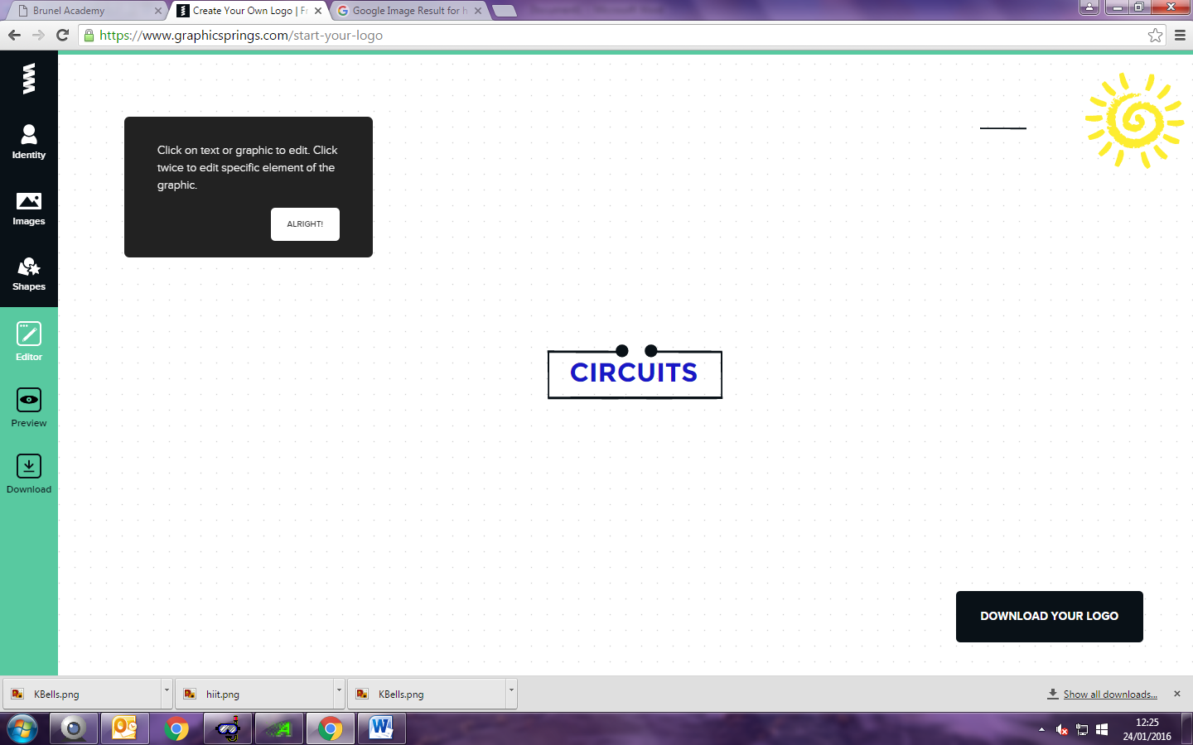

A fun, energetic, stress busting and addictive class using boxing moves and circuit style exercises. An intense total body workout for all abilities.

Boxing **Circuits**

A combination of aerobic and resistance exercises within a circuit which will give you a full body workout.

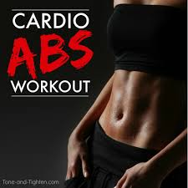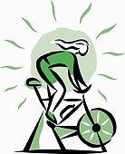

Improve your stamina and endurance, as well as your core strength.

**SPIN** A popular group class taught on stationary bicycles in the studio. It’s a great way to get a quality workout and burn a vast amount of calories by cycling to music. Bring a towel and a full water bottle.

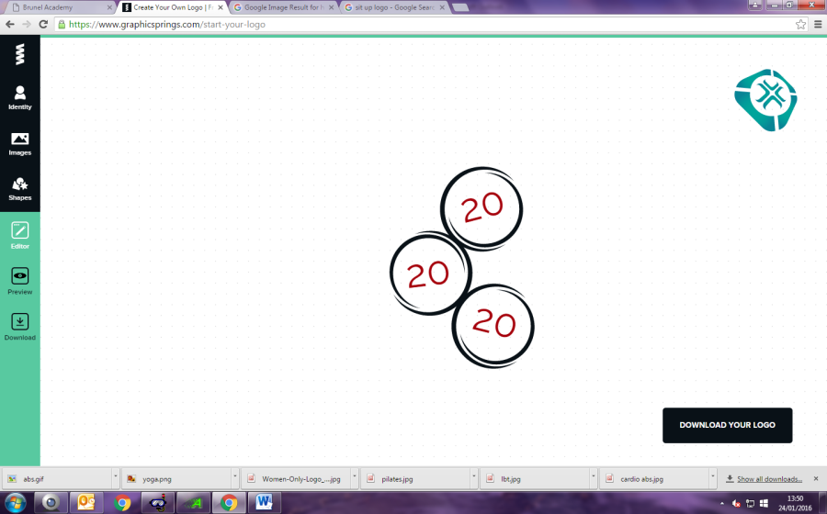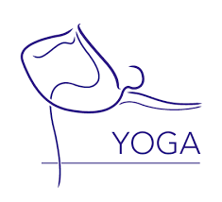

**Iyengar Yoga** focuses on alignment within the stretches and poses, helping to build flexibility, strength and coordination. This is a friendly class open for all fitness levels.

20 minutes of cardio, 20 minutes of strength training, and 20 minutes of core conditioning and stretching that gives you a full body work out!

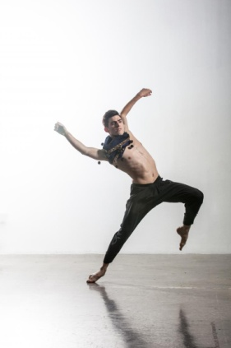

*Teacher’s Training*

A class anyone can attend if they want to improve their general fitness. A mixture of all training styles used to help you get to the fitness level you want.

A combination of dance and aerobics that’s fun and easy to follow!

